**SPRINT-4**

| **Team ID** | **PNT2022TMID07580** |
| --- | --- |
| **Project** | **IoT Based smart crop protection system for agriculture** |

STEP 1: MIT APP inventor

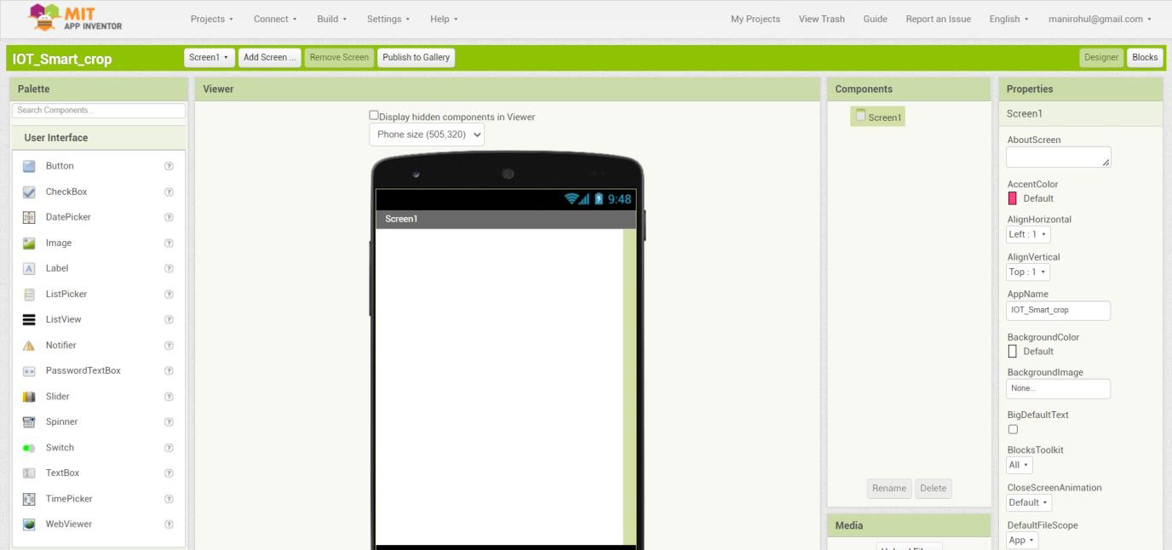

STEP 2: App interface to Display the Values.

